From Pangaea to Today …
Plate tectonics changes the face of the world. Over time, the continents change shape and
change position.
Label each of the maps below to show the following:
- South America
- North America
- Africa
- The UK
Now, write a paragraph to describe the movement over time of each place. Remember to include compass directions and how long ago it was!

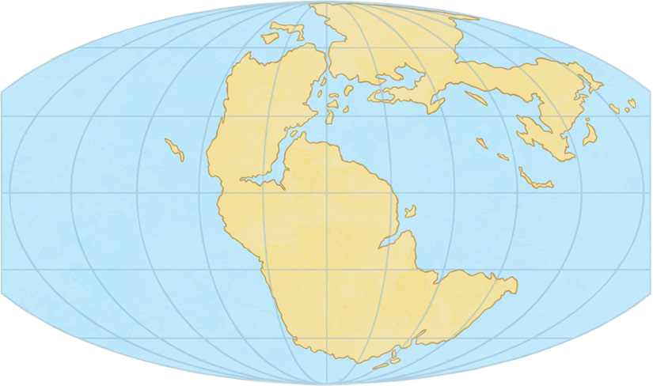
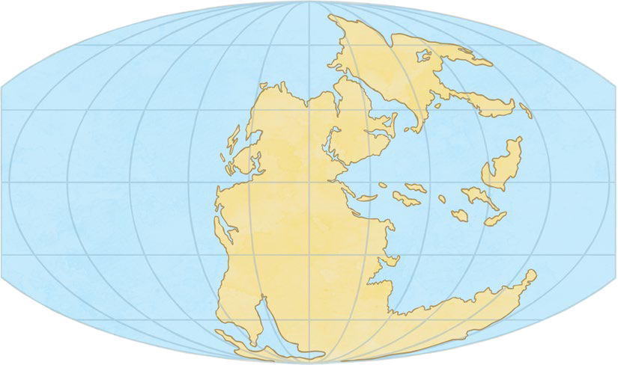

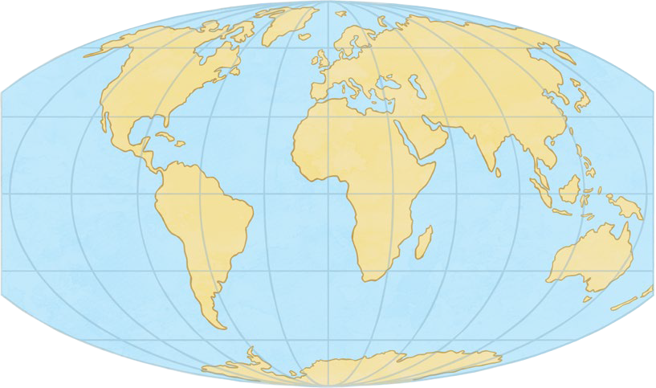
From Pangaea to Today...
